EXPERIMENT NO 18

Determination and plotting of Antenna Half power beamwidth. Aim:
To determine and plot Half Power Beamwidth (HPBW) and to determine the angular width at -3 dB points

Software required:
- SCILAB version 6.0.1

Program:
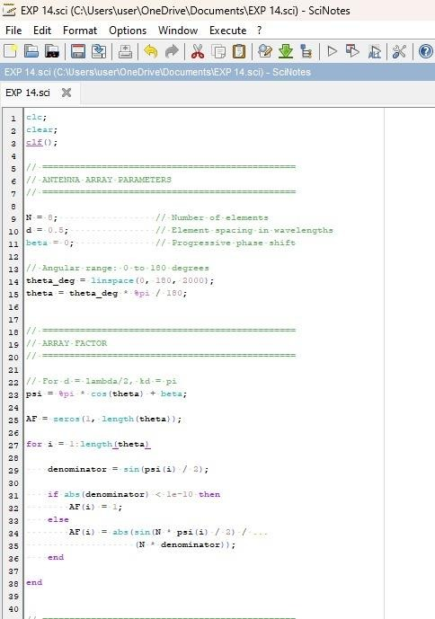

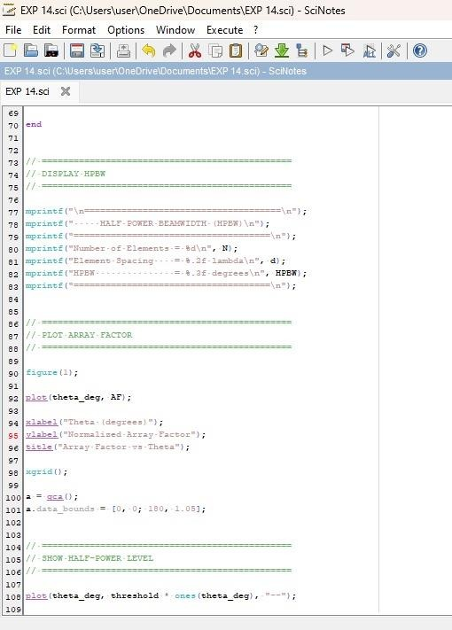

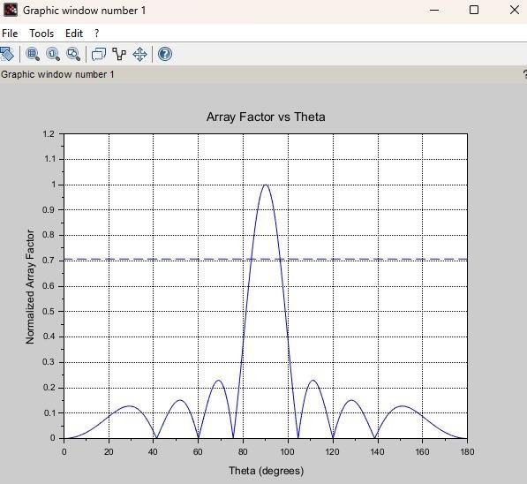
Output:

RESULT: The experiment was done and the Half power beamwidth of the given antenna was calculated. Different case studies were done.

